Credit Name

2110

Credit Assignment

E8 GuessingGame

How has your program changed from planning to coding to now? Please explain?

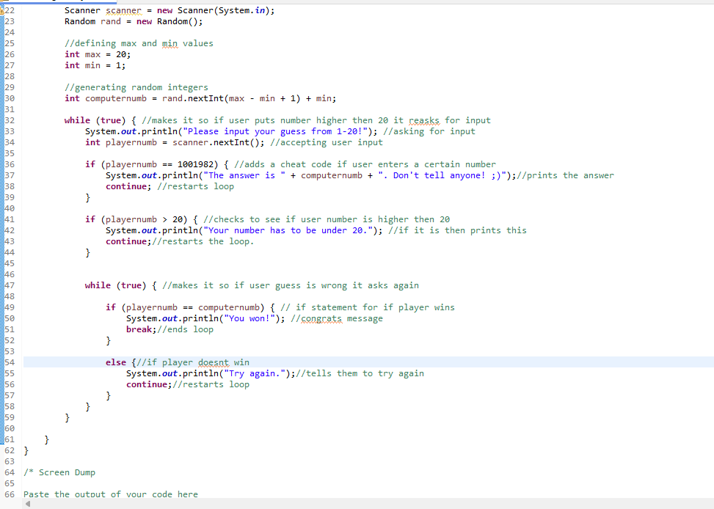

I dont think i need the second while loop. Going to try without it.

Didnt need it

